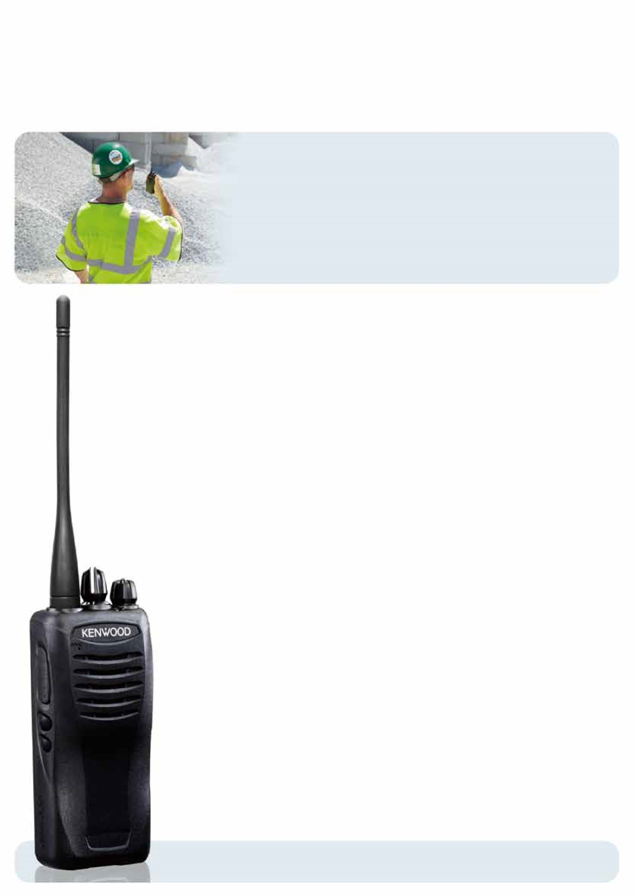
Compact VHF/UHF FM 5-WATT Radios
TK-2407/3407
KENWOOD's TK-2407/3407 portable radios deliver professional performance, enhanced features such as scan,
built-in VOX, a long battery life, as well as a sleek design. Offering 5 watts of power and MIL-STD810 & IP54/55
weatherproofing, these portables have been expertly engineered to perform in the toughest of environments.
COMPACT DESIGN
The rounded contours of the TK-2407/3407 provide
a superbly comfortable grip, while the non-slip
elastomer channel knob with improved torque
characteristics and an enlarged PTT button ensure
positive tactile response during operation.
TOUGH & WATER RESISTANT
Built to perform in the toughest environments, the
TK-2407/3407 has passed the demanding IP54/55
dust and water intrusion tests – both with and
without an optional speaker microphone. It also
meets or exceeds 11 stringent MIL-STD 810 C/D/E/F/G
environmental standards, including “driven rain”.
ENHANCED AUDIO QUALITY
As an experienced audio specialist, KENWOOD has drawn
on decades of expertise to ensure that the sound
quality of TK-2407/3407 is undeniably clearer and crisper,
as well as loud – thanks to the 36mm-diameter speaker,
which delivers up to 1 watt audio output.
ULTIMATE PERFORMANCE
Output Power is 5W for both VHF (TK-2407) and
UHF (TK-3407). Additionally, the UHF frequency
coverage on the TK-3407 is 70MHz.

MULTIPLE SIGNALING
• QT / DQT / DTMF • FleetSync
®
PTT ID, SelCall

• 2-tone
(encode/decode) • 5-tone (encode/decode)*

• Built-in MDC-1200 signaling
FleetSync
®
and MDC-1200 signaling can be
independently selected for each zone. Switching is
as simple as changing zones.
*Feature available
16
CHANNELS
The TK-2407/3407 provides ample capacity for
operating with multiple channels or radio systems,
as well as a Channel Stopper option to provide
guidance in selecting the intended channel.

2
PROGRAMMABLE FUNCTION KEYS
Both PF Keys can be programmed for any of the
many functions available, permitting customization
to suit your specific requirements. Either key can
also be programmed for an Emergency function.
LONE WORKER
This ingenious feature provides an extra layer of
security for individuals who work in remote or
hazardous areas. As long as the buttons are pressed
regularly, the radio operates normally. However, if
there is a long lapse (programmable), it will sound
an alert. And if the user does not respond to the
alert, the TK-2407/3407 will place an emergency call
to a predetermined person or group.
RADIO STUN
This function disables a lost or stolen radio over the
air, eliminating security risks.

INDEPENDENT SETTINGS PER CHANNEL

(
VOX, COMPANDER, SCRAMBLER
)
Radio channels can be programmed independently
for VOX, scrambler and compander functions. This
means a user can switch a function on or off simply
by changing channels (on the same frequency).
BUILT-IN VOICE SCRAMBLER
*
This feature provides basic protection against casual
eavesdropping. Up to 16 of 2097 possible inversion
frequencies can be chosen and assigned to any
channel.
*This function cannot be used in certain countries. Please contact
your KENWOOD dealer or further information.
GPS CONNECTIVITY
The KMC-48GPS Speaker Microphone provides an
option for GPS tracking.
OTHER FEATURES
• Priority Scan • Voice Annunciation • Password
Protection • Talk Around • Busy Channel Lockout
• Key Lock • 4-color LEDs (blue, red, orange, green)
• Scan Del/Add • Wireless Cloning • KENWOOD ESN
(
Electronic Serial Number) • Adjustable Microphone
Gain (by FPU): High or Normal • Microsoft
Windows
®
PC Programming & Tuning
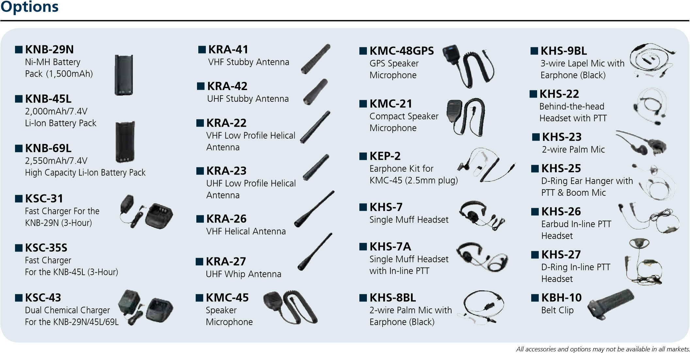
Specifications Contact an authorized KENWOOD dealer for details and complete list of all accessories and options.
MODEL
TK-2407
TK-3407
GENERAL
MODEL
TK-2407
TK-3407
RECEIVER (Measurements made per TIA/EIA-603)
M | 136-174MHz | 450-520MHz
M2  Number of Channels  Channel Spacing |  | 400-470MHz
 | 16ch
Wide / Narrow  Operating Voltage  Battery Life (5-5-90, battery saver OFF) | 25kHz / 12.5kHz
 | 7.5V DC ± 20%
KNB-45L | More than 12 hours
KNB-29N | More than 9 hours
KNB-69L  Operating Temperature Range*  Frequency Stability  Antenna Impedance  Dimensions (W x H x D), Weight | More than 16 hours
 | -30°C ~ +60°C
 | ± 2.5 ppm (-30°C ~ +60°C)
 | 50 Ω
Radio only | 54 x 122 x 33.7mm, 165g
with KNB-45L | 54 x 122 x 33.7mm, 281g
with KNB-29N | 54 x 122 x 33.7mm, 365g
with KNB-69L | 54 x 122 x 37.8mm, 305g
Frequency Range Sensitivity (12dB SINAD)
Wide / Narrow  Adjacent CH Selectivity | 0.25 µV / 0.28µV
Wide / Narrow  Intermodulation Distortion | 70 dB / 60dB
Wide / Narrow  Spurious Response  Audio Distortion | 70 dB / 60dB
 | 70 dB
 | Less than 10%
Audio Output 1 W / 12Ω (Internal Speaker )
500
mW / 8Ω (External Output
)
TRANSMITTER (Measurements made per TIA/EIA-603)
RF Power Output
5
/ 1W
Spurious Response
70
dB
FM Hum & Noise
Wide / Narrow
45
dB / 40dB
Audio Distortion
Less than 5%
Modulation (Wide / Narrow)
16
K0F3E, 11K0F3E
Specifications shown are typical.
Specifications are subject to change without notice, due to advancements in technology. FleetSync® is a registered trademark of JVC KENWOOD Corporation.
*Operating temperature range of the KNB-29N/45L/69L: -10°C ~ +60°C Windows® is a registered trademark of Microsoft Corporation in the United States and other countries.
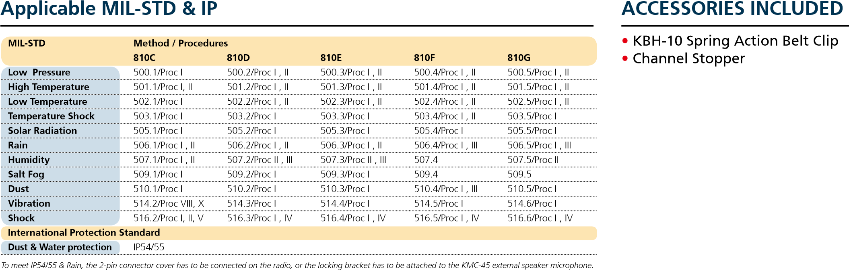
CL762M-E-2

