specification sheet
Motorola CP1660
Commercial Portable Two-Way Radio

Full keypad provides easy accessibility to change channels or place a selective call (DTMF signaling).
Built-in simple voice scrambling for increased privacy.
Built-in DTMF signaling provides caller identification and private communication.
VOX ready for hands-free communication—
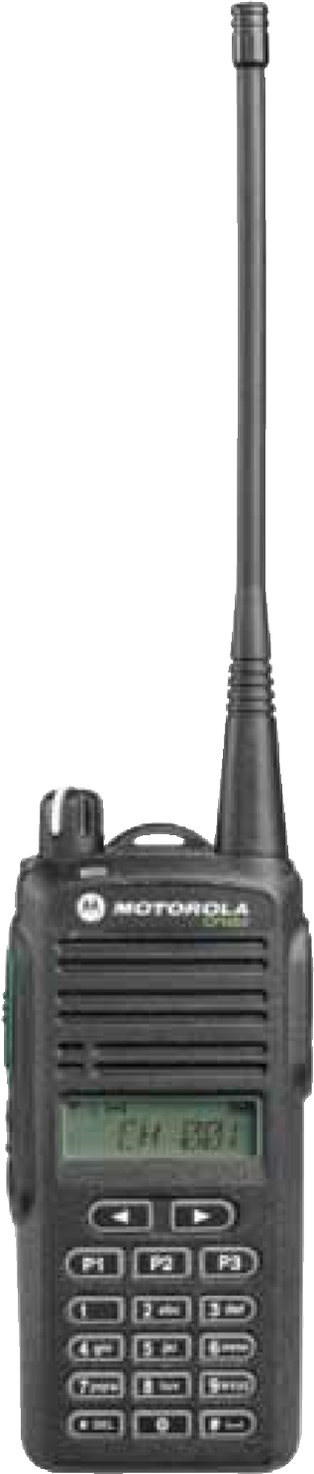
keeps users hands free for the job at hand.
Tighter specifications provide enhanced rejection of interference so you can get your message through clearly.
X-Pand technology provides crisp, clear and strong audio quality.
Multi-channel capability—99 channels to support communication amongst all your employees.
Enhanced functionality, ease of use, reliable communication
Easy and prompt communication with your workforce is vital to improving response time, strengthening employee efficiency and increasing customer satisfaction. Motorola’s two-way radios provide a durable, high-quality voice communication solution that helps your business increase productivity and provide excellent customer service. | Ideal for light manufacturing, retail, hospitality services, property and real estate management. The Motorola CP1660 Commercial Portable radio brings you quality features you need at a competitive price. With its full keypad for increased ease of use, extensive feature set, and ergonomic shape for comfortable handling in a durable, lightweight, compact design, you can enhance communication while increasing efficiency and productivity.
User programmable feature allows customization of radio profiles while on the go.
Standard LiIon battery provides up to 11 hours (5/5/90 duty cycle) of battery life at high power to meet the demands of your employee’s work shift. A high-capacity LiIon battery option is available for those with longer shift requirements or increased communication needs.
High power—5 watt (VHF) / 4 watt (UHF)— adjustable power levels help extend battery life.
5 programmable buttons—enabling easy, one-touch access to up to 10 user-selected features.
Talkaround capability enabling communication even when a repeater is not being used.
Rapid-rate drop-in charging—charge standard capacity batteries in less than 3 hours with the included drop-in charger.
Easy-to-handle, lightweight, compact design.
A wide range of Motorola Original® audio, energy and carrying accessories, as well as Mag One™ audio accessories, provide an affordable option for light duty radio users.
Recommended
Accessories#
PMMN4013—Remote
Speaker Microphone with
3.5mm audio jack, IP54 PMLN5003—Lightweight Temple Transducer with
In-line Microphone and
PTT PMLN5001—D-Style
Earpiece with In-line Microphone and PTT PMLN4442—Earbud with In-line Microphone and
PTT/VOX switch ( Mag One ) HMN9754—2-Wire
Surveillance Kit, Beige
#For a complete listing of accessories, please refer to the accessories brochure AF4-06-015

CP1660 Radio Specifications*

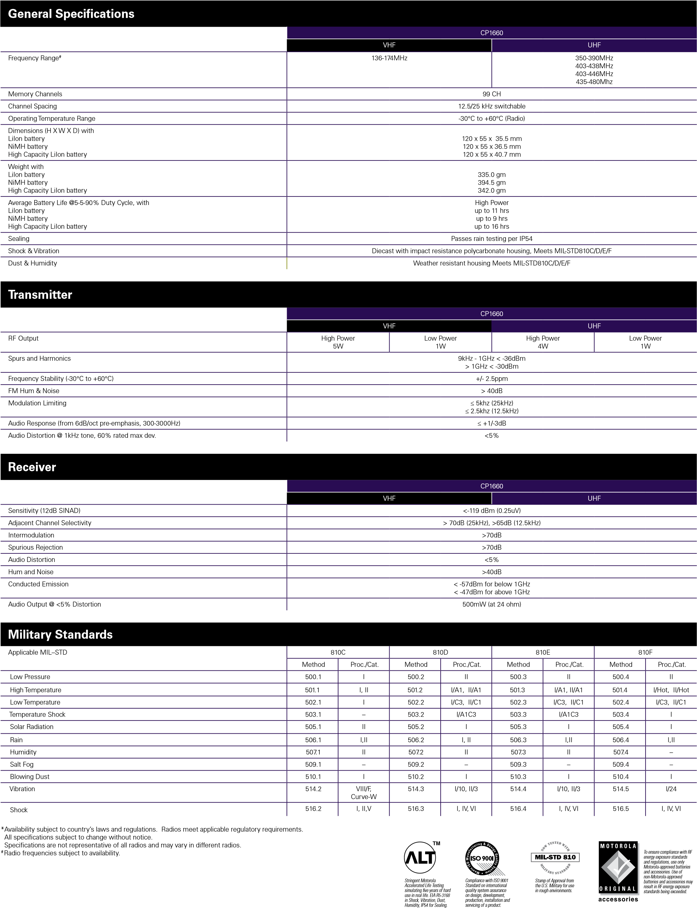
MOTOROLA and the Stylized M Logo are registered in the U.S. Patent and Trademark Office. All other product or service names are the property of their registered owners. © Motorola, Inc. 2009
AC3-04-032 REV.1

